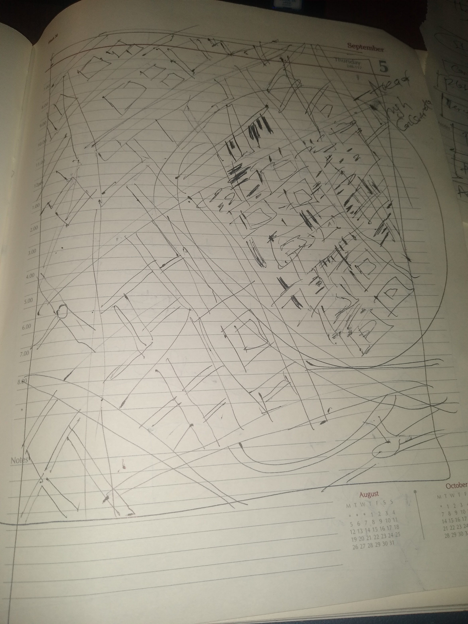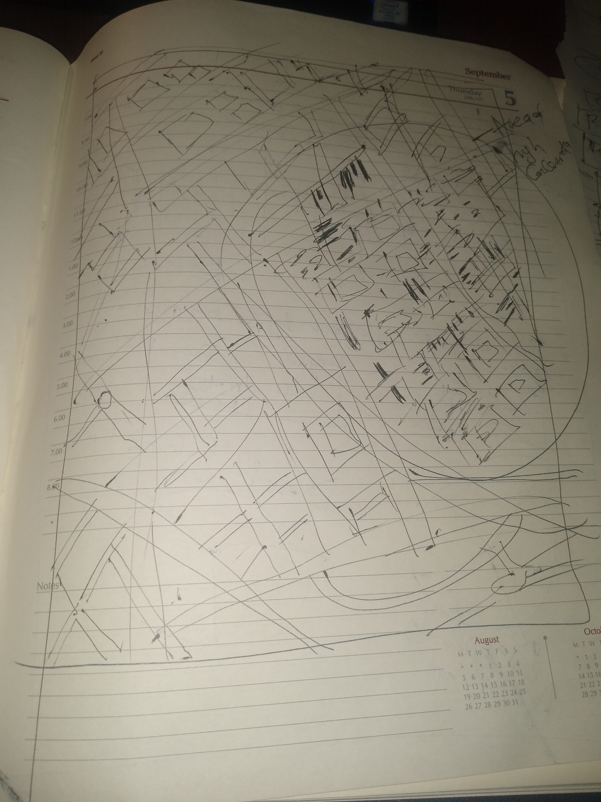



**Design Methodology**

The rough draft of my thought pattern on how to create a map using D3 to illuistrate the John Snow’s heroic efforts and landmark achievement in isolating the caue of the cholera outbreak in London in 1854.

The sketch above presumably just gives an overbiew od the subsequent steps that I would be undertaking to explore and analyze the the map through viziualization using D3. I drew rough skecthes of the the London street, shaded the areas where the cholera outbreak is largely concentrated, showed a schematic on how I want to reperesnt death by gender and age group with different color codings. Also I showed the statistcial diagrammatic represengtations to reveal the varing degrees of casulaties in various locations around London at the time of the incident.

Map Plot Approach

The maps were rendered using the pumps , streets and death locations as the unique causal factors.

I developed the visualization iteratively. I started by rendering the map, the pumps, and the death locations as the minimum viable product. Following the rubric provided by the instructor be I added annotated graphs to show death by gender, age and total number of deaths that occurred at that time.

In addition I did color coding for the female and male gender to show disparities in the number of deaths. The age group data cannot be validated based on the information from the assignment majorly because it was not captured during the time of occurrence. In order to provide a statistical groups of death per age groups I equally demonstrated that with the aid of the graph. Moving the mouse cursor on the different points on the graph will reveal data of interest to the viewer or user. The YouTube link to the video explanation is<https://youtu.be/eAHmA56yYa0>

**Conclusions and Inference**

Death locations are strongly correlated with the location of the Broad Street pump.

There were more significant deaths of male than female victims.

The 0-10 age range were more vulnerable and died

Death is more pronounced in the middle aged groups too

The total number of deaths hit all time high on September 2nd 1854 numbering 143 people

Fewer deaths among those older than 80 years